|  |  |
| --- | --- |
| Sprint 4 | **ESTABLISHING THE TEXT TO SPEECH SERVICES** |
| Team ID | PNT2022TMID17729 |
| Project Name | Project – Personal Assistance for Seniors Who Are Self-Reliant |

# INSTALLATION OF WATSON VERSION: Code:

Pip install –upgrade “ibm-watson>=6.1.0”

# Result:

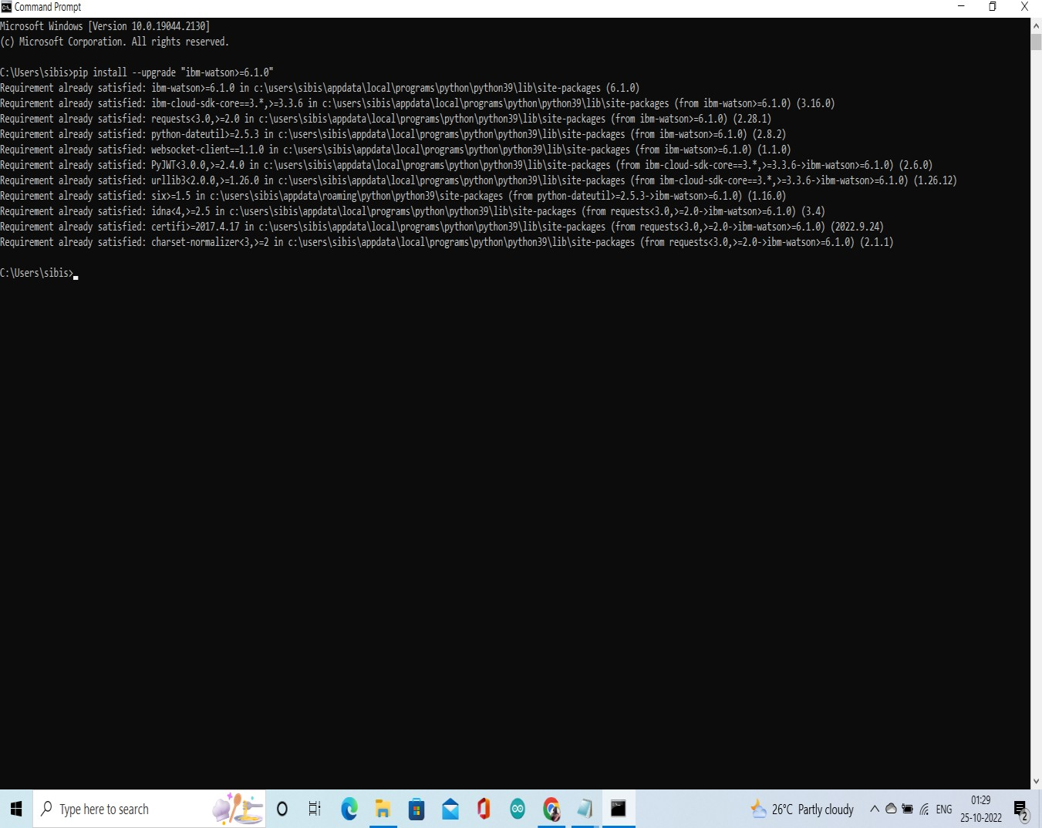

1. **COPYING CREDENTIALS FOR API AND URL:**

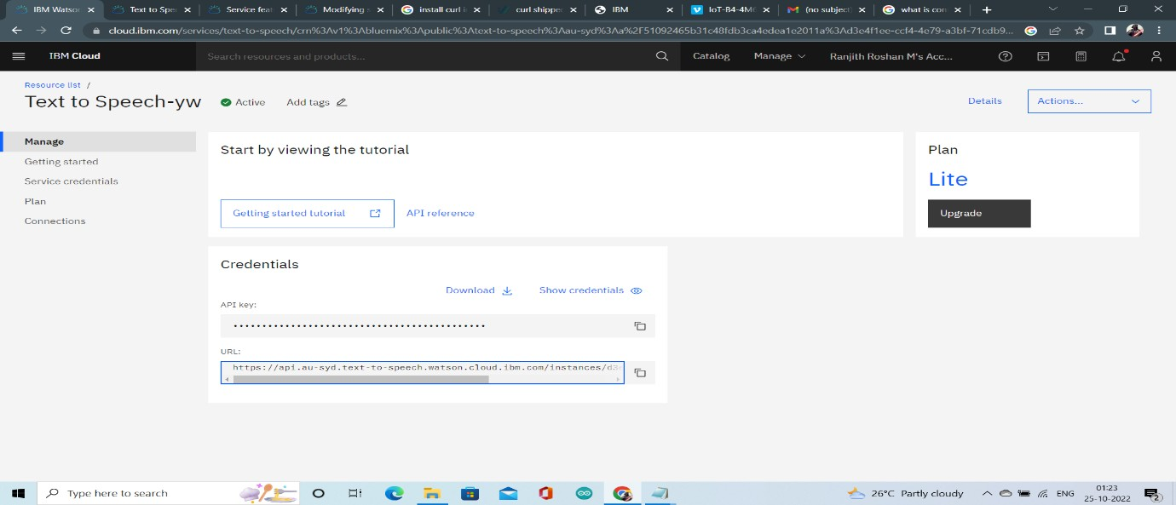

# PROGRAM FOR ACCESSING APIs OF TTS SERVICE:

from ibm_watson import TextToSpeechV1

from ibm_cloud_sdk_core.authenticators import IAMAuthenticator

authenticator = IAMAuthenticator('1SuMpBioLx9PuvKX- wnvMh3Z3lQbUKcXZErWleXdmY9j')

text_to_speech = TextToSpeechV1( authenticator=authenticator

)

text_to_speech.set_service_url('https://api.au-syd.text-to- speech.watson.cloud.ibm.com/instances/d3e4f1ee-ccf4-4e79-a3bf-71cdb9fdf9e8')

with open('hello_world.wav', 'wb') as audio_file: audio_file.write(

text_to_speech.synthesize( 'Take Crocin Now',

voice='en-US_AllisonV3Voice', accept='audio/wav'

).get_result().content)

# Execution and Run

